

**DEPARTMENT: INFORMATION AND COMMUNICATION TECHNOLOGY**

**OPTION: INFORMATION TECHNOLOGY**

**TOPIC: ITP REPORT IN IOT WITH IDA TECHNLOGY (Smart class).**  
  
  
Name: **NIYIGABA Claude**

Supervisor’s name: **NZABAREGERIMANA EMMANUEL**

Kigali, Nov 18, 2022

# DECLARATION

I, NIYIGABA Claude, I declare that the presented report of the internship titled “**SMART CLASS”** is uniquely prepared by me after the completion of two months’ work at IDA TECHNOLOGHY.

I also confirm that the report is only prepared for my academic requirement and to fill internship not for any other purpose. It might not be used in the interest of the opposite party of the corporation.

Name: **NIYIGABA Claude**

Signature:

Date: Nov, 18/2022

# APPROVAL

This report is hereby approved by the organization of IDA Technology

Supervisor’s name: **NZABAREGERIMANA EMMANUEL**

Contents

DECLARATION i

APPROVAL ii

ABSTRACT iv

Chapter One: INTROCTION 1

Chapter Two: Activity and implementation 2

2.1 First Activity: Installation of tools used [4] 2

2.2 The Second Activity how to get temperature 2

2.2.0 Define [5] 2

2.2.1 DHT11 Sensor 3

2.2.3 What is Relative Humidity? [8] 3

2.2.4 How the DHT11 Measures Humidity and Temperature 4

2.2.5 How to Set Up the DHT11 on an Arduino 7

2.2.6 Programming Arduino 9

2.3 Activity Three: How MQ3 Alcohol Sensor Works? & Interface it with Arduino 9

2.3.1 MQ3 Alcohol Sensor [9] 9

2.3.2 Internal structure of MQ3 Alcohol Sensor 10

2.3.3 How Does the MQ3 Alcohol Sensor Work? 12

2.3.4 MQ3 Alcohol Sensor Module Hardware Overview 13

2.3.4 Technical Specifications 15

2.3.5 MQ3 Alcohol Sensor Module Pinout 16

2.3.6 Calibrating the MQ3 Alcohol Sensor 16

2.3.7 Experiment 1 – Measuring Alcohol Concentration using Analog Output (A0) 17

2.3.8 Wiring 17

2.3.9 Finding the threshold values 18

2.3.9 Threshold Values and formula 19

2.4 Experiment 2 – Detecting the Presence of Alcohol using Digital Output (D0) 19

2.4.1 Wiring 19

2.5 sSetting the threshold 20

Chapter Three: Lesson, experience and skills 22

3.1 About my experience reached with it 22

3.1 Arduino, Nodemcu and full Arduino IDE 23

3.2 Circuit diagram and PCB Board 24

Chapter Four: Challenge, Limitation, resolution and area improvement 25

4.1 Limitation of MQ3 25

4.1.0 Introduction 25

4.1.1 Benefits or advantages of Alcohol sensor [10] 25

4.2 DHT11 25

4.2.0 DHT11 limitation 25

4.2.1 The advantages and disadvantages of a humidity sensor? [7] 25

Chapter Five: CONCLUTION 26

References 27

Appendices 28

2.1 For DHT11 [6] 28

2.2 MQ3 with D0 and their Output [9] 30

# ABSTRACT

This report presents development of an IoT-Based student attendance monitoring system using University of Port Harcourt as a case study. In the University of Port Harcourt, attainment of 75% attendance of every student is one of the criteria for a student to be qualified to sit for any course in any of the semester’s examination. The system is aimed to effectively monitor the 75% attendance of every student. The system composed of hardware and web application. The hardware consists of; Power supply, RFID sensor, Esp 32 controller, thin film transistor (TFT) Liquid Crystal display and Light emitting diode (LED) while the software consists of; Webpage, Embedded C language and my structured query language (MySQL) Database. The RFID sensor registers the students during the course registration exercise and authenticates students during attendance in class. The Esp 32 microcontroller with WiFi enabled connects the system to the webpage for data storage and displays information via TFT LCD. MySQL is used for online database for students’ attendance storage system. The course lecturers are allowed to gain access only to their class attendance register platform while the Head of department would have access to all the attendance registers online. The system was designed and tested by registering students and taking attendance with optimum performance.

*Keywords—IoT; MySQL Database; TFT LCD; RFID sensor; Javas; Esp 32 Controller, PHP; HTML*

# Chapter One: INTROCTION

This industrial attachment can facility a student to improving workshop activity and practice experience. It make me motivate for learn how market founded so we get how client contact with workers.

This internship is a key for create special worker competence to the market and generate market strategy. As I say, my internship were made in IDATECH [1] (innovation develop Africa Technology). As trainer in IOT and they workshop tools for make experienced in circuit embedded system and developing more project such as internet of thing in digital life and make world easy to as anything however you are accessible it.

IOT: It’s a physical object that connects to the Internet. It can be a fitness tracker, a thermostat, a lock or appliance – even a light bulb.

Imagine shoes that track your heartbeat… and can flag potential health problems. You don’t have to imagine – these “smart” shoes already exist!

IDATECH a special purpose are We dedicate our effort in providing affordable ICT services and ICT informal education to public and private companies as well as primary and secondary schools...

It help me to get access to **IamTheCode Platform** [2]

Get a 12 weeks of blended learning with iamThecode by accessing iamThecode digital Platform for free. As study more course online and get certificate.

I choose this company because my target and mission refer by IDa Mission

By 2030, We have a mission to create 10 000 jobs and make 500 000 youths, women, refugees and girls from lower income families in Rwanda to be software engineers, IoT Technicians and data Scientists.

And they support student internship To contribute to our mission of job creation, Hire our trainees in Python, Nodejs, Java, react, Nextjs, Flutter and Data science, c++ and Arduino IDE. [3]

# Chapter Two: Activity and implementation

The firstly we study same Sensor, HTML, CSS, PHP, MSQL, wokwi, cicuito and general project

## 2.1 First Activity: Installation of tools used [4]

How to Install the Arduino IDE Software on Windows 10 #Arduino_1

Step 1: Download File Arduino IDE. ...

Step 2: License Agreement. ...

Step 3: Installation Option. ...

Step 4: Installation Folder. ..

Step 5: Installing Proses. ...

Step 6: Installation Complete. ...

Step 7: Open Arduino IDE. ...

Step 8: Display Arduino IDE.

## 2.2 The Second Activity how to get temperature

## 2.2.0 Define [5]

The [DHT11 humidity and temperature sensor](https://www.adafruit.com/product/386) [6] make it really easy to add humidity and temperature data to your DIY electronics projects. It’s perfect for remote weather stations, home environmental control systems, and farm or garden monitoring systems.

In this tutorial, I’ll first go into a little background about humidity, then I’ll explain how the DHT11 measures humidity. After that, I’ll show you how to connect the DHT11 to an Arduino and give you some example code so you can use the DHT11 in your own projects.

## 2.2.1 DHT11 Sensor

The DHT11 is a basic, ultra low-cost digital temperature and humidity sensor. It uses a capacitive humidity sensor and a thermistor to measure the surrounding air and spits out a digital signal on the data pin (no analog input pins needed).It’s fairly simple to use, but requires careful timing to grab data. The only real downside of this sensor is you can only get new data from it once every 2 seconds, the sensor readings can be up to 2 seconds old.

[Compared to the DHT22](http://www.adafruit.com/product/385), [7] this sensor is less precise, less accurate, and works in a smaller range of temperature/humidity, but it is smaller and less expensive.

*Technical Details*

* Low cost
* 3 to 5V power and I/O
* 2.5mA max current use during conversion (while requesting data)
* Good for 20-80% humidity readings with 5% accuracy
* Good for 0-50°C temperature readings ±2°C accuracy
* No more than 1 Hz sampling rate (once every second)
* Body size 15.5mm x 12mm x 5.5mm
* 4 pins with 0.1" spacing

## 2.2.3 What is Relative Humidity? [8]

The DHT11 measures *relative humidity*. The relative humidity is the amount of water vapor in air vs. the saturation point of water vapor in the air. At the saturation point, water vapor starts to condense and accumulate on surfaces forming dew.

The saturation point changes with air temperature. Cold air can hold less water vapor before it becomes saturated, and hot air can hold more water vapor before it becomes saturated.

The formula to calculate relative humidity is:

[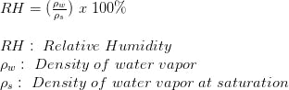](javascript:openLightBox('5a89bd0ee9',%200);)

The relative humidity is expressed as a percentage. At 100% RH, condensation occurs, and at 0% RH, the air is completely dry.

## 2.2.4 How the DHT11 Measures Humidity and Temperature

The DHT11 detects water vapor by measuring the electrical resistance between two electrodes. The humidity sensing component is a moisture holding substrate with electrodes applied to the surface. When water vapor is absorbed by the substrate, ions are released by the substrate which increases the conductivity between the electrodes. The change in resistance between the two electrodes is proportional to the relative humidity. Higher relative humidity decreases the resistance between the electrodes, while lower relative humidity increases the resistance between the electrodes.

The DHT11 measures temperature with a surface mounted [NTC temperature sensor](http://www.amazon.com/gp/product/B00GD471PO/ref=as_li_qf_sp_asin_il_tl?ie=UTF8&camp=1789&creative=9325&creativeASIN=B00GD471PO&linkCode=as2&tag=circbasi-20&linkId=UJTHZ5Z3JDMKGOCK)(thermistor) built into the unit. To learn more about how thermistors work and how to use them on the Arduino, check out this [Arduino Thermistor Temperature Sensor Tutorial.](https://www.circuitbasics.com/arduino-thermistor-temperature-sensor-tutorial)

With the plastic housing removed, you can see the electrodes applied to the substrate:

[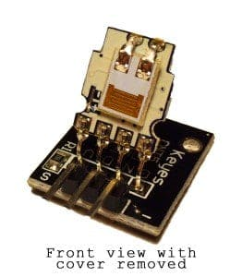](javascript:openLightBox('02d00c3812',%200);)

An IC mounted on the back of the unit converts the resistance measurement to relative humidity. It also stores the calibration coefficients, and controls the data signal transmission between the DHT11 and the Arduino:

[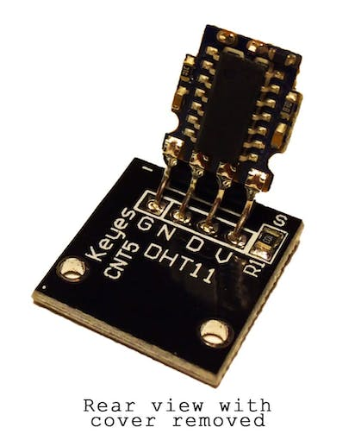](javascript:openLightBox('2fce98142d',%200);)

The DHT11 uses just one signal wire to transmit data to the Arduino. Power comes from separate 5V and ground wires. A 10K Ohm pull-up resistor is needed between the signal line and 5V line to make sure the signal level stays high by default (see the datasheet for more info).

There are two different versions of the DHT11 you might come across. One type has four pins, and the other type has three pins and is mounted to a small PCB. The PCB mounted version is nice because it includes a surface mounted 10K Ohm pull up resistor for the signal line. Here are the pinouts for both versions:

[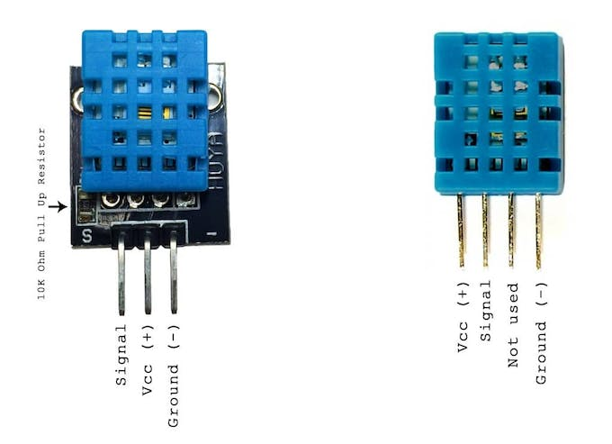](javascript:openLightBox('16d7096b5b',%200);)

## 2.2.5 How to Set Up the DHT11 on an Arduino

Wiring the DHT11 to the Arduino is really easy, but the connections are different depending on which type you have.

[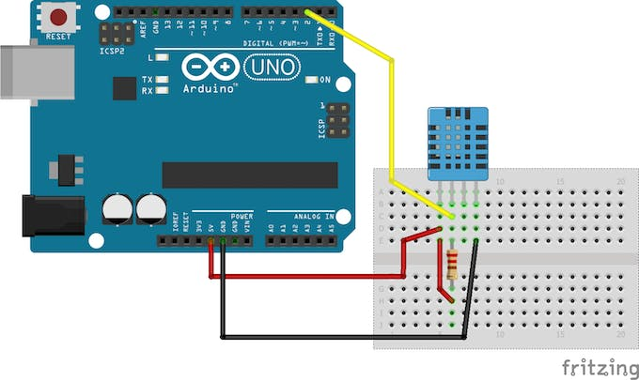](javascript:openLightBox('f5c06930c2',%200);)

[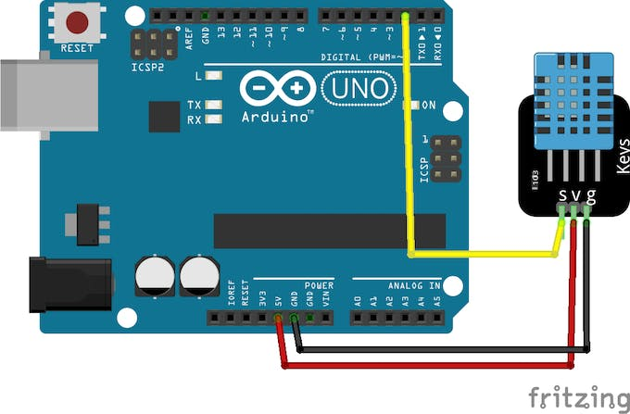](javascript:openLightBox('f5c06930c2',%201);)

* VCC - red wire Connect to 3.3 - 5V power. Sometime 3.3V power isn't enough in which case try 5V power.
* Data out - white or yellow wire
* Not connected
* Ground - black wire

Simply ignore pin 3, it's not used. You will want to place a 10 K ohm resistor between VCC and the data pin, to act as a medium-strength pull up on the data line. The Arduino has built-in pull-ups you can turn on but they're very weak, about 20-50K

## 2.2.6 Programming Arduino

You should have the [Arduino IDE](https://www.arduino.cc/en/Main/Software) software running at this time. Next, it’s necessary to install the DHT Sensor library, which can be done through the Arduino Library Manager:

Sketch→Include Library→Manage Libraries…

Enter “dht” in the search field and look through the list for the “DHT sensor library by Adafruit.” Click the “Install” button, or “Update” from an earlier version.

IMPORTANT: As of version 1.3.0 of the DHT library you will also need to install the Adafruit_Sensor library, which is also available in the Arduino Library Manager.

## 2.3 Activity Three: How MQ3 Alcohol Sensor Works? & Interface it with Arduino

Give your next Arduino project a nose for alcohol by including the MQ3 alcohol sensor module. This sensor detects the presence of alcohol in the air as well as its concentration. So, if you want to build your own breathalyzer to determine how much alcohol is in someone’s breath, the MQ3 alcohol sensor module is an excellent choice.

## 2.3.1 MQ3 Alcohol Sensor [9]

The MQ3 sensor is one of the most widely used in the MQ sensor series. It is a MOS (Metal Oxide Semiconductor) sensor. Metal oxide sensors are also known as **Chemiresistors** because sensing is based on the change in resistance of the sensing material when exposed to alcohol.

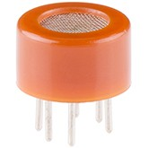

The MQ3 alcohol sensor operates on 5V DC and consumes approximately 800mW. It can detect alcohol concentrations ranging from 25 to 500 ppm.

What does the concentration of 1 ppm mean?

Parts-per-million, or ppm for short, is the most commonly used unit for measuring gas concentration. ppm is simply the ratio of one gas to another. For example, 500ppm of alcohol means that if you could count a million gas molecules, 500 would be alcohol and the remaining 999500 would be other gases.

## 2.3.2 Internal structure of MQ3 Alcohol Sensor

The MQ3 is a heater-driven sensor. It is therefore covered with two layers of fine stainless steel mesh known as an “anti-explosion network”. It ensures that the heater element inside the sensor does not cause an explosion because we are sensing flammable gas (alcohol).

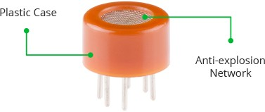

It also protects the sensor and filters out suspended particles, allowing only gaseous elements to pass through the chamber.

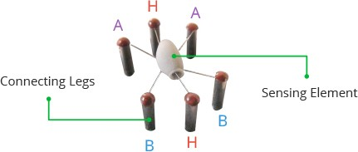

When the outer mesh is removed, the sensor looks like this. The sensing element and six connecting legs that extend beyond the Bakelite base form the star-shaped structure. Two (H) of the six leads are in charge of heating the sensing element and are linked together by a Nickel-Chromium coil (a well-known conductive alloy).

The remaining four signal-carrying leads (A and B) are connected with platinum wires. These wires are connected to the body of the sensing element and convey slight variations in the current flowing through the sensing element.

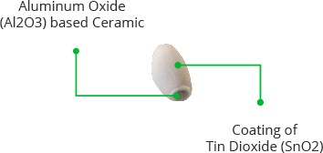

The tubular sensing element is made of Aluminum Oxide (AL2O3) based ceramic with a Tin Dioxide coating (SnO2). Tin Dioxide is the most important material because it is sensitive to alcohol. The ceramic substrate, on the other hand, improves heating efficiency and ensures that the sensor area is continuously heated to the working temperature.

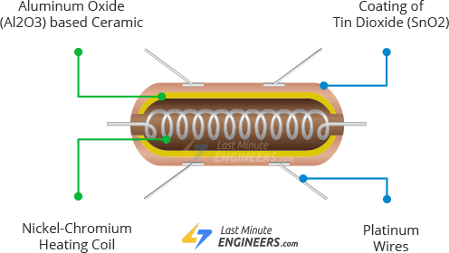

To summarize, the Heating System is composed of a Nickel-Chromium coil and an Aluminum Oxide-based ceramic, while the Sensing System is composed of Platinum wires and a Tin Dioxide coating.

## 2.3.3 How Does the MQ3 Alcohol Sensor Work?

When a SnO2 semiconductor layer is heated to a high temperature, oxygen is adsorbed on the surface. When the air is clean, electrons from the conduction band of tin dioxide are attracted to oxygen molecules. This creates an electron depletion layer just beneath the surface of the SnO2 particles, forming a potential barrier. As a result, the SnO2 film becomes highly resistive and prevents electric current flow.

In the presence of alcohol, however, the surface density of adsorbed oxygen decreases as it reacts with the alcohol, lowering the potential barrier. As a result, electrons are released into the tin dioxide, allowing current to freely flow through the sensor.

## 2.3.4 MQ3 Alcohol Sensor Module Hardware Overview

The MQ3 alcohol sensor is simple to use and has two different outputs. It not only provides a binary indication of the presence of alcohol, but also an analog representation of its concentration in air.

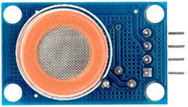

The sensor’s analog output voltage (at the A0 pin) varies in proportion to the alcohol concentration. The higher the concentration of alcohol in the air, the higher the output voltage; the lower the concentration, the lower the output voltage. The animation below shows the relationship between alcohol concentration and output voltage.



This analog signal is digitized by an LM393 High Precision Comparator and made available at the Digital Output (D0) pin.

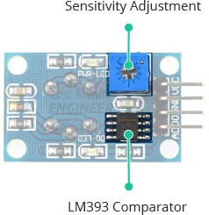

The module includes a potentiometer for adjusting the sensitivity of the digital output (D0). You can use it to set a threshold so that when the alcohol concentration exceeds the threshold value, the module outputs LOW otherwise HIGH.

Rotating the knob clockwise increases sensitivity and counterclockwise decreases it.

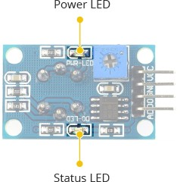

In addition, the module has two LEDs. The Power LED illuminates when the module is turned on, and the Status LED illuminates when the alcohol concentration exceeds the threshold value.

## 2.3.4 Technical Specifications

Here are the specifications:

|  |  |
| --- | --- |
| Operating voltage | 5V |
| Load resistance | 200 KΩ |
| Heater resistance | 33Ω ± 5% |
| Heating consumption | <800mw |
| Sensing Resistance | 1 MΩ – 8 MΩ |
| Concentration Range | 25 – 500 ppm |
| Preheat Time | Over 24 hour |

## 2.3.5 MQ3 Alcohol Sensor Module Pinout

Let’s take a look at the pinout now.

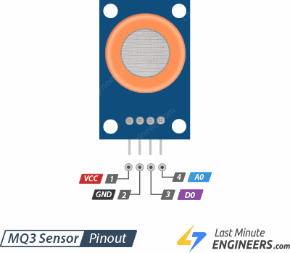

VCC supplies power to the module. Connect it to the 5V output of your Arduino.

GND is the ground pin.

D0 indicates the presence of alcohol. D0 becomes LOW when the alcohol concentration exceeds the threshold value (as set by the potentiometer), and HIGH otherwise.

A0 produces analog output voltage proportional to alcohol concentration, so a higher concentration results in a higher voltage and a lower concentration results in a lower voltage.

## 2.3.6 Calibrating the MQ3 Alcohol Sensor

Because the MQ3 is a heater-driven sensor, the calibration of the sensor may drift if it is left in storage for an extended period of time.

When first used after a long period of storage (a month or more), the sensor must be fully warmed up for 24-48 hours to ensure maximum accuracy.

If the sensor has recently been used, it will only take 5-10 minutes to fully warm up. During the warm-up period, the sensor typically reads high and gradually decreases until it stabilizes.

## 2.3.7 Experiment 1 – Measuring Alcohol Concentration using Analog Output (A0)

In our first experiment, we will read the analog output to measure the alcohol concentration and estimate the level of alcohol intoxication.

## 2.3.8 Wiring

Let us connect the MQ3 alcohol sensor to the Arduino.

Begin by connecting the VCC pin to the Arduino’s 5V pin and the GND pin to the Arduino’s Ground pin. Finally, connect the module’s A0 output pin to Analog pin #0 on the Arduino.

The following image shows the wiring.

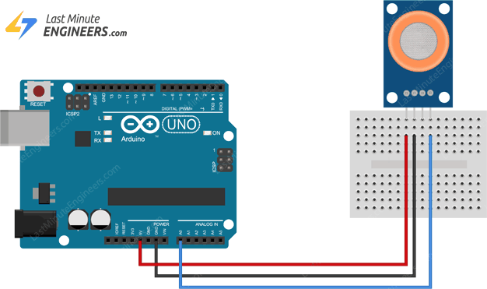

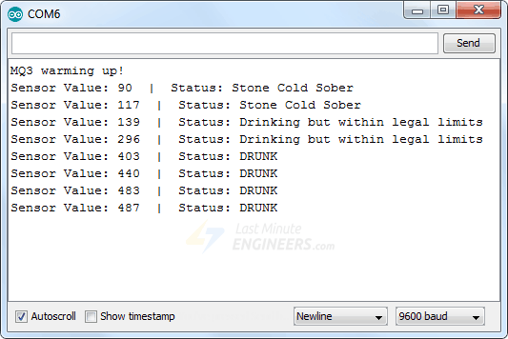

## 2.3.9 Finding the threshold values

To estimate the level of alcohol intoxication, you need to record the values your sensor outputs when you blow on it before and after consuming alcohol.

When you run the sketch, you should see readings similar to the ones below:

* In the absence of alcohol (around 120)
* In the presence of alcohol (around 500)

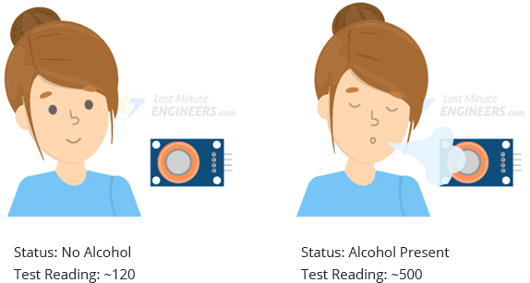

This test may require some trial and error. Once you have the readings, you can use them as a threshold to trigger an action.

## 2.3.9 Threshold Values and formula

The sketch below estimates the level of alcohol intoxication using the following threshold values:

* < 120 is sober
* 120-400 is drinking – but within legal limits
* > 400 is drunk.

## 2.4 Experiment 2 – Detecting the Presence of Alcohol using Digital Output (D0)

In our second experiment, we will use digital output to detect the presence of alcohol.

## 2.4.1 Wiring

We’ll reuse the previous experiment’s circuit. Simply disconnect the connection to the ADC pin and connect the D0 pin on the module to the Arduino’s digital pin #8.

The following image shows the wiring.

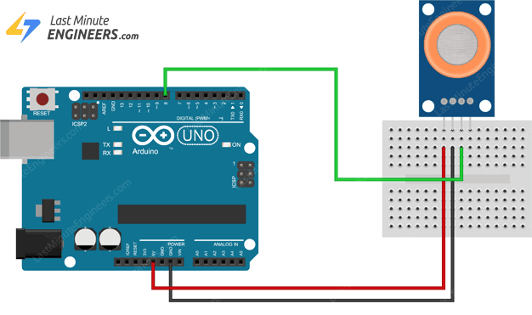

## 2.5 sSetting the threshold

The module has a built-in potentiometer for setting an alcohol concentration threshold above which the module outputs LOW and the status LED lights up.

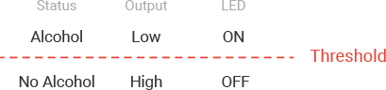

Now, to set the threshold, let the alcohol vapors enter the sensor and turn the pot clockwise until the Status LED is on. Then, turn the pot back counterclockwise just until the LED goes off.

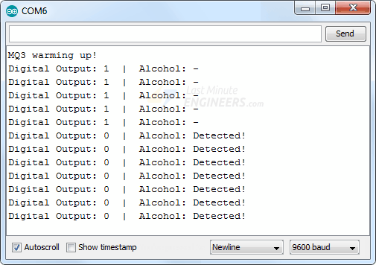

# Chapter Three: Lesson, experience and skills

## 3.1 About my experience reached with it

On this chapter it contain more task and more experiences so the Firstly is get how ARDUINO it work, and connect same sensor like mq3, sound sensor, tft, RFID reader, connection with hardware and software, design circuit diagram and develop IOT project using Arduino with c++ and python. It’s summary because I saw and read more.

## 3.1 Arduino, Nodemcu and full Arduino IDE

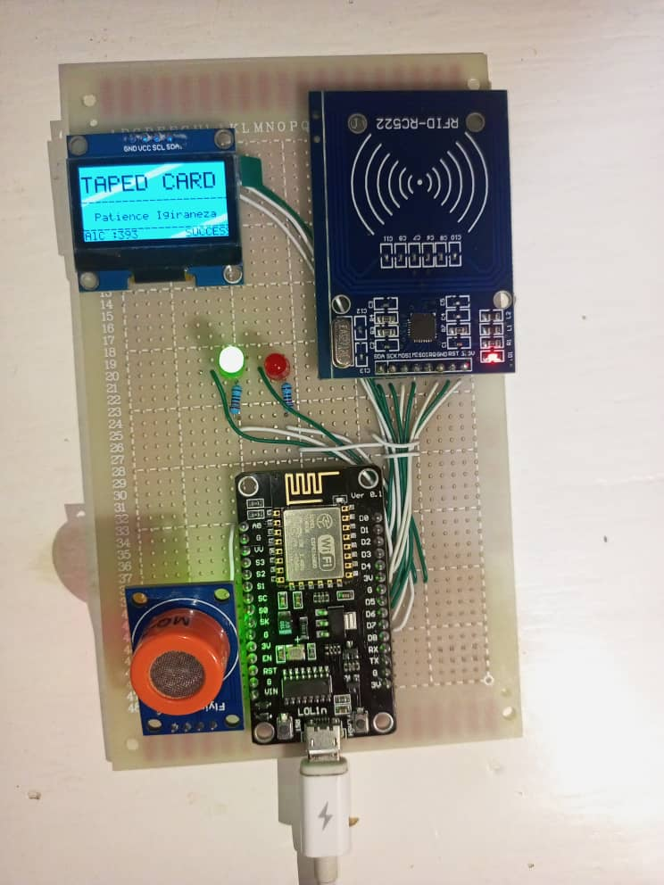

## Circuit diagram and PCB Board

1. Pcb board

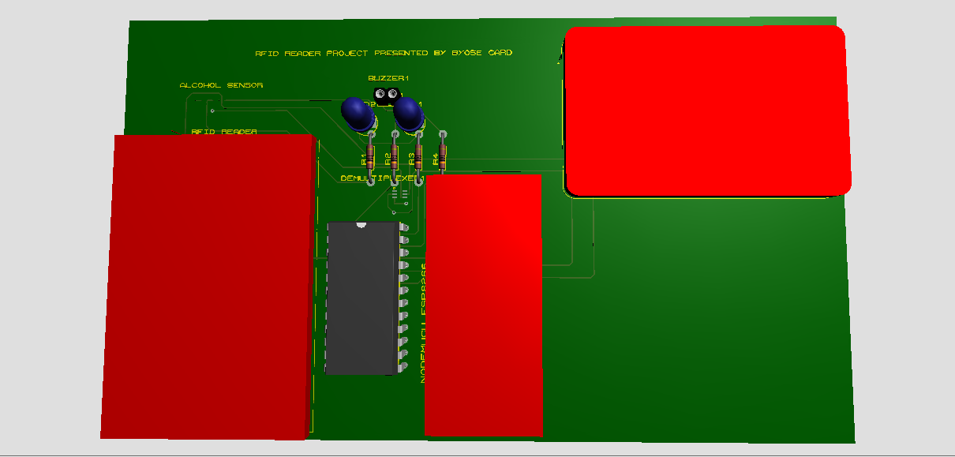

B, Circuit design

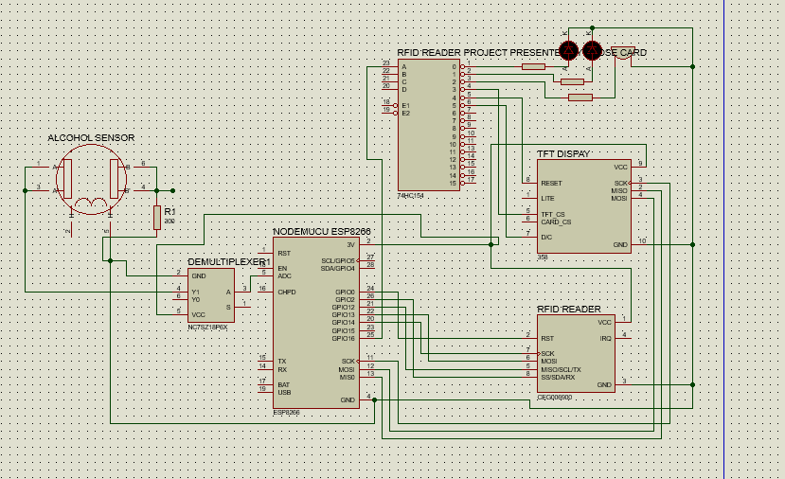

# Chapter Four: Challenge, Limitation, resolution and area improvement

## 4.1 Limitation of MQ3

4.1.0 Introduction  
The small semiconductor device which detects presence of alcohol gas in the air is known as alcohol sensor or alcohol detector. MQ3 and MQ135 are the common alcohol sensors commonly found for use. MQ-3 is used for various applications such as breath analyzer, portable alcohol detection, background sensing device, gas level over limit alarm, environmental monitoring equipment and so on.

MQ-3 sensor uses SnO2 material which offers low conductivity in fresh air. When alcohol gas exists, the conductivity of sensor increases. In other words, **resistance of sensor reduced when alcohol concentration increases**.

## 4.1.1 Benefits or advantages of Alcohol sensor [10]

Following are the benefits or **advantages of Alcohol sensor**:  
➨It is available at cheaper price.

➨It has long life cycle.  
➨It offers high stability.  
➨It has high sensitivity which results into faster response time.  
➨It needs simple drive circuit and it is simple to use.  
➨It is easy to interface with microcontrollers.  
➨Alcohol sensor based car protects you when you are drunk. During such condition, your other family member can drive. Moreover it will protect your car from unauthorized access.

4.1.2 Drawbacks or disadvantages of Alcohol sensor [11]

Following are the drawbacks or **disadvantages of Alcohol sensor**:  
➨Breath analyzers using alcohol detection are available at high prices. Moreover they have shorter lifetime.  
➨Breath analyzers require continuous re-calibration.

## 4.2 DHT11

## 4.2.0 DHT11 limitation

The only limitation on this sensor is **you can only get new data from it once every 2 seconds**.

## 4.2.1 The advantages and disadvantages of a humidity sensor? [7]

|  |  |  |
| --- | --- | --- |
| **Humidity sensing method** | **Advantages** | **Disadvantages** |
| Hygrometric | ➨It is easy to clean.  ➨It is simple in construction.  ➨It is lower in cost.  ➨It is usable in contaminated environments. | ➨It is limited accuracy.  ➨It has limited measurement range.  ➨It is slow in measurement. |

# Chapter Five: CONCLUTION

The IoT based student attendance monitoring system provides a reliable data management and storage system for monitoring the attendance performance of students. This system can also help shape student’s attitude to learning. Since the aim of the University educational system is to train and educate students in character and learning, this work would help University checkmate students during learning period. Using Optical fingerprint and Esp 32 IoT microcontroller, the student’s attendance is recorded and sent to the online database which can be retrieved by the lecturers and HODs when the need arises. The system is designed to assists the University to promote excellence and make decisions pertaining student’s performance in attending classes and siting for examination. This system adopts Wi-Fi communication technology and protocol that enables it communicates with smart devices such as android smartphones, personal computers etc. It also aimed at providing help to the goal of the institution by monitoring and keeping proper records of the attendance of the students, store data online and ease in calculating the percentage attendance of student to ascertain if a student met the standard requirement before entering examination hall. This would aid IDA TECHNOLOGY of Port Harcourt to trace students that are qualified to sit for any examination and sanction those not qualified.

# References

|  |  |
| --- | --- |
| [1] | "https://www.idatech.rw/," 60 days 09-11 2022. [Online]. Available: https://www.idatech.rw/. |
| [2] | "https://www.idatech.rw/aipe/," IOT , 2022. [Online]. Available: https://www.idatech.rw/aipe/. |
| [3] | O. E. M. P. E. D.-F. C. R. &. L. G. R. Amestica, "An experimental comparison of Arduino IDE compatible platforms for digital control and data acquisition applications," IEEE CHILEAN Conference on Electrical, Electronics Engineering, Information and Communication Technologies, 2019, November, pp. pp. 1-6). |
| [4] | A. a. M. F. Al Dahoud, "NodeMCU V3 for fast IoT application Development," Notes 5 (2018. |
| [5] | D. A. K. a. S. D. Srivastava, Measurement of Temperature and Humidity by using Arduino Tool and DHT11, International Research Journal of Engineering and Technology (IRJET) , (2018): 876-878. |
| [6] | https://www.adafruit.com/product/386, Composer, *https://www.adafruit.com/product/386.* [Sound Recording]. dafrui. |
| [7] | B. O. G. D. A. N. ihai, How to use the DHT22 sensor for measuring temperature and humidity with the arduino board, Acta Uiversitatis Cibiniensis–Technical Series 68, 2016. |
| [8] | J. Lstiburek, "Relative humidity," in *Building Science Corporation online, www. buildingscience*, com/resources/moisture/relative_humidity_0402. pdf)., dated April (2002. |
| [9] | D. S. M. S. S. S. Sahu P, Alcohol detection based engine locking system using MQ-3 sensor., Chicago: International Research Journal of Engineering and Technology, 2017. |
| [10] | D. S. A. S. D. a. C. A. Garg, "Alcohol Detection System in Vehicle Using Arduino". |
| [11] | K. P. M. C. &. C. R. Kumar, "IOT BASED ALCOHOL DETECTION FOR INDUSTRY WORKERS.," GPH-International Journal Of Computer Science and Engineering, 2(03), 01-09., 2019. |

# Appendices

## 2.1 For DHT11 [6]

* 1. First we have to include the "DHT.h" Library.

#include "DHT.h"

* 1. Then define the digital pin in which the DHT11 is connected to.

#define DHTPIN 2 // Digital pin connected to the DHT sensor

* 1. Now define the type of DHT Sensor

#define DHTTYPE DHT11 // DHT 11

//#define DHTTYPE DHT22 // DHT 22 (AM2302), AM2321

//#define DHTTYPE DHT21 // DHT 21 (AM2301)

// Connect pin 1 (on the left) of the sensor to +5V

// NOTE: If using a board with 3.3V logic like an Arduino Due connect pin 1

// to 3.3V instead of 5V!

// Connect pin 2 of the sensor to whatever your DHTPIN is

// Connect pin 4 (on the right) of the sensor to GROUND

// Connect a 10K resistor from pin 2 (data) to pin 1 (power) of the sensor

// Initialize DHT sensor.

DHT dht(DHTPIN, DHTTYPE);

* 1. Inside the void setup function, Initialize the Serial Communication and the DHT Sensor

void setup() {

Serial.begin(9600);

Serial.println(F("DHTxx test!"));

dht.begin();

}

* 1. Now, inside the void loop function, let's measure the readings.

void loop() {

// Wait a few seconds between measurements.

delay(2000);

// Reading temperature or humidity takes about 250 milliseconds!

// Sensor readings may also be up to 2 seconds 'old' (its a very slow sensor)

float h = dht.readHumidity();

// Read temperature as Celsius (the default)

float t = dht.readTemperature();

// Read temperature as Fahrenheit (isFahrenheit = true)

float f = dht.readTemperature(true);

// Check if any reads failed and exit early (to try again).

if (isnan(h) || isnan(t) || isnan(f)) {

Serial.println(F("Failed to read from DHT sensor!"));

return;

}

// Compute heat index in Fahrenheit (the default)

float hif = dht.computeHeatIndex(f, h);

// Compute heat index in Celsius (isFahreheit = false)

float hic = dht.computeHeatIndex(t, h, false);

Serial.print(F(" Humidity: "));

Serial.print(h);

Serial.print(F("% Temperature: "));

Serial.print(t);

Serial.print(F("C "));

Serial.print(f);

Serial.print(F("F Heat index: "));

Serial.print(hic);

Serial.print(F("C "));

Serial.print(hif);

Serial.println(F("F"));

}

## 2.2 MQ3 with D0 and their Output [9]

#define MQ3pin 8

int sensorValue; //variable to store sensor value

void setup() {

Serial.begin(9600); // sets the serial port to 9600

Serial.println("MQ3 warming up!");

delay(20000); // allow the MQ3 to warm up

}

void loop() {

sensorValue = digitalRead(MQ3pin); // read digital output pin

Serial.print("Digital Output: ");

Serial.print(sensorValue);

// Determine the status

if (sensorValue) {

Serial.println(" | Alcohol: -");

} else {

Serial.println(" | Alcohol: Detected!");

}

delay(2000); // wait 2s for next reading

}

You should see similar output on the serial monitor.

